RESEARCH PLAN

SmartSteth: A Convolutional Neural Network (CNN) Driven Auscultation Instrument Using Lung Sound Analysis for Early Respiratory Disease
Detection in Satellite Clinics
Kiesha Mekhaela B. Relatado, Ahnycca Krish N. Malimban, Teokislev Gazelle J. Jompella
Science, Technology, Engineering, and Mathematics – Senior High School Department
Puerto Princesa City National Science High School, Palawan

- RATIONALE
This study aims to evaluate the performance, usability, and community acceptance of a convolutional neural network (CNN)–driven auscultation instrument that analyzes respiratory sounds to detect subtle acoustic variations associated with lower respiratory tract diseases. The device, SmartSteth, is designed for the early detection of conditions such as asthma, bronchiolitis, and pneumonia in rural areas surrounding Puerto Princesa City, Palawan. Traditional auscultation with a stethoscope is often limited in these settings due to insufficient training, outdated equipment, and logistical barriers (Topaloglu et al., 2025). Although AI‑enabled respiratory sound diagnostics have demonstrated high accuracy in technologically advanced regions (Laguarta et al., 2020; Han et al., 2022), their deployment remains concentrated in urban centers, thereby widening healthcare disparities (Rajpurkar et al., 2022).
Asthma, bronchiolitis, and pneumonia may present distinct acoustic signatures—such as wheezing, crackles, and abnormal breath sounds that can be captured through auscultated respiratory signals and analyzed using machine learning techniques (Topaloglu et al., 2025; IEEE, 2025). Recent studies confirm the feasibility of sound‑based screening in low‑resource environments, with lightweight neural models enabling real-time analysis even in settings with limited connectivity and infrastructure. In the Philippines, particularly the Mimaropa region, community health workers frequently face challenges of misdiagnosis and underreporting due to diagnostic limitations and geographic isolation.
This research therefore seeks to (1) validate the diagnostic accuracy of SmartSteth, (2) assess its integration into local health workflows, and (3) determine its potential to enhance healthcare accessibility by equipping frontline workers with real‑time, data‑driven insights. Ultimately, the study aims to promote equitable access to advanced medical technologies in underserved communities.
RESEARCH QUESTION(S), HYPOTHESIS(ES), GOAL(S), EXPECTED OUTCOMES
  - Research Questions
  - What are the perceived challenges and needs in diagnosing lower respiratory tract diseases (e.g., pneumonia, asthma, bronchiolitis) in low‑resource settings, particularly with respect to:
- Availability of diagnostic tools,
- Training and knowledge of health workers,
- Environmental and infrastructural limitations,
- Time constraints during patient consultations,
- Referral systems and access to higher-level care, and
- Community awareness and health-seeking behavior?

  - What design features do health workers prioritize in a lower respiratory tract disease screening device, specifically regarding:
- Form factor (size, weight, ergonomics),
- Interface layout (simplicity, clarity, iconography),
- Portability (battery life, ruggedness, ease of transport),
- Ease of maintenance and cleaning,
- Compatibility with existing workflows, and
- Cost and affordability?

  - Which performance metrics best evaluate SmartSteth’s efficiency in capturing and classifying respiratory sounds for lower respiratory tract disease screening, including:
- Signal-to-noise ratio (SNR),
- Frequency resolution,
- Latency (real-time responsiveness),
- Sensitivity to different respiratory sound types,
- Robustness in noisy environments, and
- Consistency across different patient profiles?

  - How intuitive and effective is SmartSteth’s graphical user interface (GUI) for frontline health workers, in terms of:
- Ease of navigation,
- Clarity of instructions and icons
- Accessibility for users with low digital literacy
- Multilingual support
- Error prevention and feedback mechanisms
- Training time required for proficiency

  - What factors influence acceptance and trust in SmartSteth among health workers and community leaders, particularly with respect to:
- Perceived usefulness and reliability
- Cultural compatibility and relevance
- Previous experience with digital tools
- Community endorsement and peer influence
- Transparency of diagnostic results
- Support and training provided

  - What makes SmartSteth different from other digital stethoscopes, particularly in terms of:
- Interface and usability
- Portability and offline use
- Maintenance and cleaning
- Fit with existing workflows in rural clinics
- Cost and affordability for community health facilities

  - Hypotheses
Ho: There is no significant difference between the user needs and preference scores of SmartSteth and the acceptance and trust scores among health workers and community stakeholders in diagnosing lower respiratory tract diseases in low-resource settings.

Ha: There is a significant difference between the user needs and preference scores of SmartSteth and the acceptance and trust scores among health workers and community stakeholders in diagnosing lower respiratory tract diseases in low-resource settings.

  - Goals
This study aims to develop and validate SmartSteth, a convolutional neural network (CNN)–driven auscultation instrument for the early detection of lower respiratory tract diseases (e.g., Pneumonia, Asthma, Bronchiolitis) using respiratory sound analysis. The research will determine the device’s diagnostic accuracy against established clinical standards, evaluate its usability and integration within rural health unit workflows, and assess its potential to improve healthcare accessibility. By equipping frontline health workers with real‑time, data‑driven insights, SmartSteth seeks to strengthen clinical decision‑making, reduce diagnostic delays, and promote equitable access to AI‑enabled medical technologies in underserved and resource‑limited communities.

  - Expected Outcomes
This study is expected to contribute to the United Nations Sustainable Development Goals Goal 3 Good Health and Well‑being, Goal 9 Industry, Innovation and Infrastructure, Goal 10 Reduced Inequalities, and Goal 17 Partnerships for the Goals by developing a widely accessible CNN‑driven auscultation instrument tailored to the diagnostic needs of rural communities near Puerto Princesa City, Palawan. By focusing on the early detection of lower respiratory tract diseases (e.g., pneumonia, asthma, bronchiolitis) through respiratory sound analysis, the research aims to reduce diagnostic delays, strengthen local health system capacity, and improve referral timeliness. Anticipated outcomes include validated diagnostic performance of SmartSteth against clinical standards, demonstrated usability and workflow integration in rural health units, increased confidence and diagnostic capability among frontline health workers, and measurable improvements in healthcare accessibility and equity. Ultimately, the study seeks to promote equitable access to AI‑enabled medical technologies and support sustainable, community‑centered innovation in resource‑limited settings.

PROCEDURES
The diagram below summarizes the core steps and structure of the methodology used in this study:

Gathering Lung Sound Dataset

Requirements Gathering

Training of Artificial Intelligence

Assembling of the Device

Web Development

Artificial Intelligence Integration

Device Finalization
Figure 1. Schematic Diagram
The respiratory sound analysis begins with gathering the lung sound dataset, which provides the audio samples needed to train the system. This is followed by requirements gathering, where the functional and technical specifications of the device and software are determined. The recorded lung sounds are then used in the training of the artificial intelligence model, where a TensorFlow model learns to classify respiratory sounds into categories such as tuberculosis, pneumonia, pertussis, or normal breathing. Simultaneously, the assembling of the device takes place, integrating the INMP441 MEMS microphone inside the stethoscope and connecting it to the ESP32 microcontroller. Next, web development ensures that the uploaded audio data can be processed and displayed on a user-friendly interface. Artificial intelligence integration then allows the web server to classify the received audio in real time, providing probability scores for each respiratory category. Finally, device finalization confirms that the system works as intended, delivering accurate classification results on the website interface for health workers or researchers to review and analyze.
Gathering Lung Sound Dataset
The study involves collecting an accurate lung sound dataset, which is critical for training and validating the artificial intelligence model. The dataset consists of auscultated respiratory sounds, including recordings of normal breathing as well as sounds associated with lower respiratory tract diseases such as Asthma, Pneumonia, and Bronchiolitis. The lung sounds are captured using digital stethoscopes or high-quality MEMS microphones, ensuring clear audio signals with minimal noise interference. These recordings are organized and labeled accurately based on the patient's medical diagnosis to create a reliable dataset that will serve as the foundation for the AI classification model.
Requirements Gathering
The functional and technical specifications necessary to develop the respiratory sound classification system. This includes identifying the hardware components, such as the ESP32 microcontroller and INMP441 MEMS microphone, and defining the software requirements, including audio processing algorithms, web server dependencies, and AI model compatibility. Input from health professionals is considered to understand real-world needs, such as the ability to classify lung sounds quickly and accurately and display results in a user-friendly format. Additional considerations include Wi-Fi connectivity for data transmission, storage capabilities, security of patient data, and a clear interface for visualizing results,

Training of Artificial Intelligence
Artificial intelligence training is a core component of the project. The labeled lung sound dataset is preprocessed to remove noise, normalize volume levels, and convert audio into a suitable format, such as Mel-spectrograms. These spectrograms are then uploaded and trained using Edge Impulse, a platform for building embedded machine learning models, where a Convolutional Neural Network (CNN) is employed to detect patterns in the lung sounds associated with different respiratory conditions. The model undergoes multiple sections of training and validation to optimize its performance, reduce overfitting, and improve accuracy. Learning rate, batch size, and number of false positives are carefully tuned to achieve reliable classification results. The final trained model is then ready to be deployed for real-time lung sound analysis.

Assembling of the Device
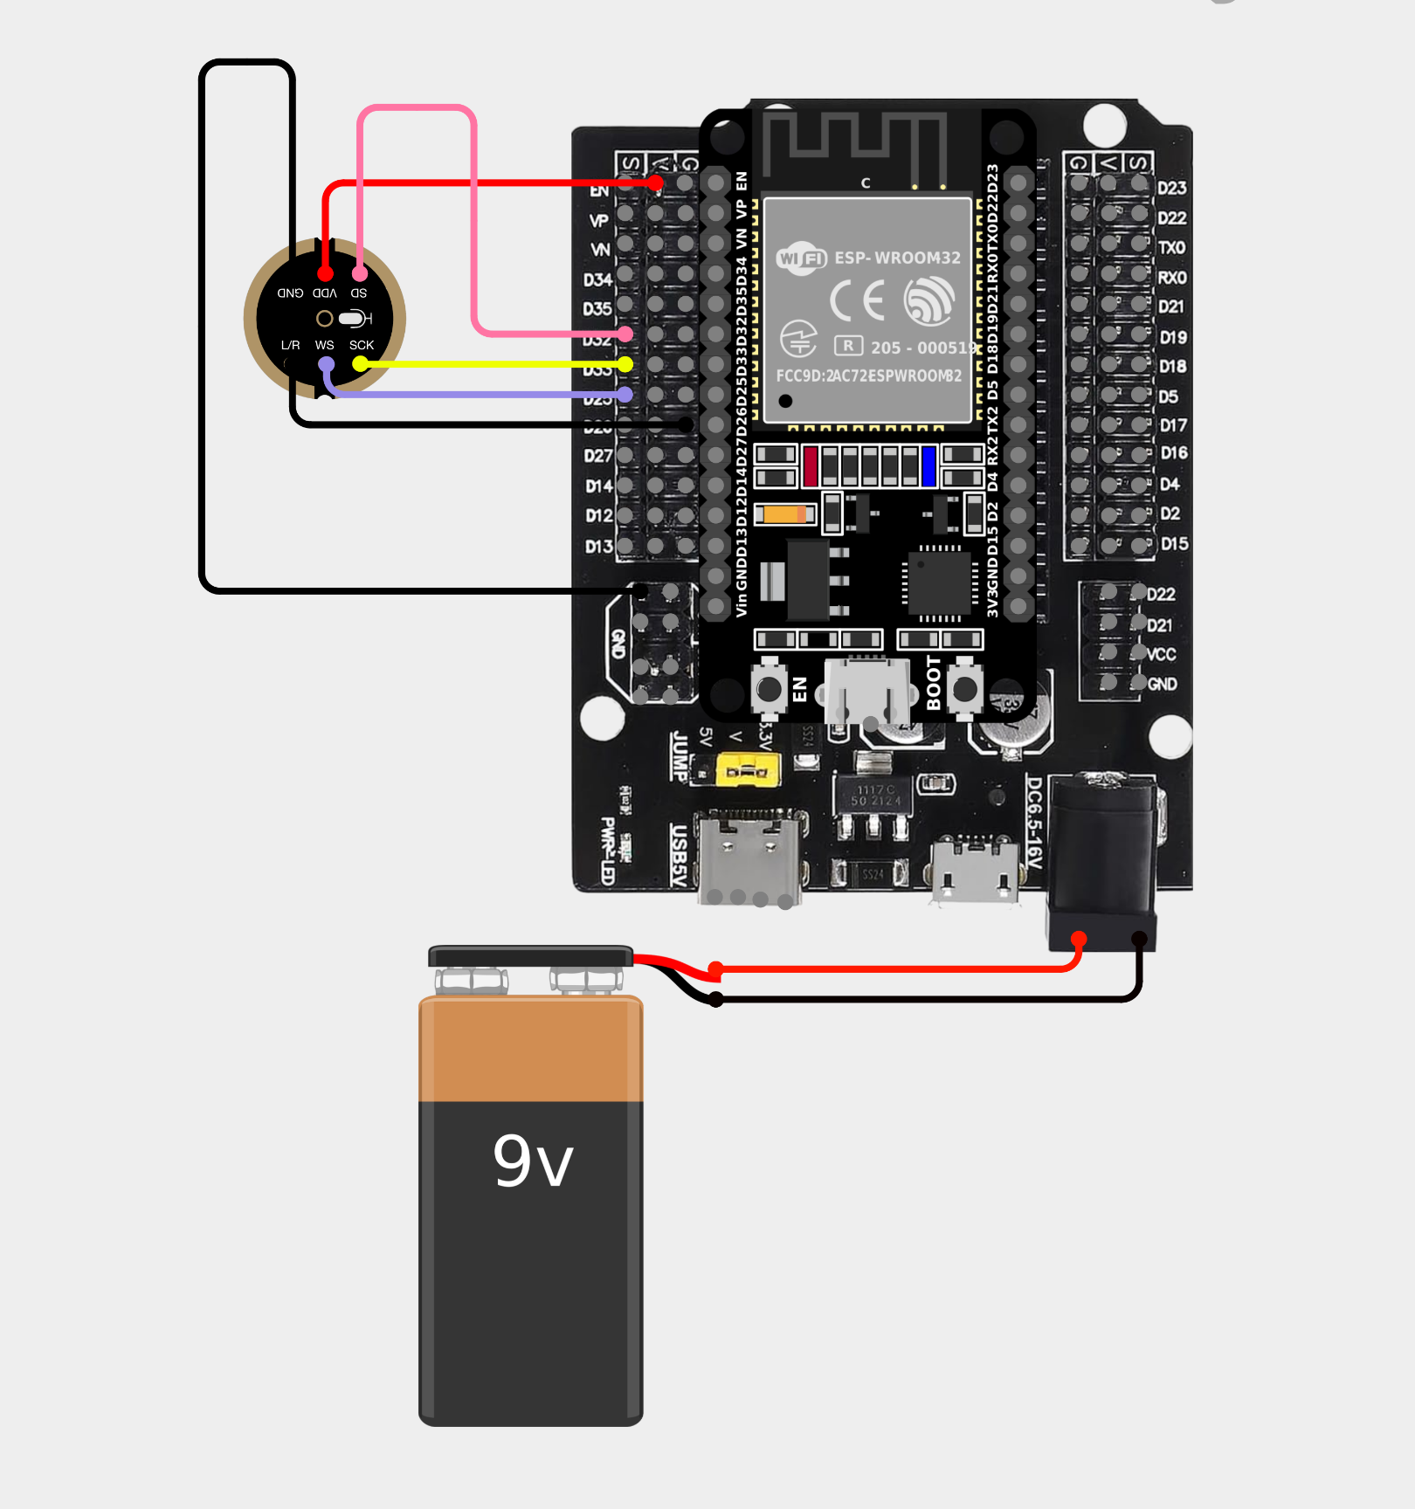
Figure 2. Cirkit Designer Diagram
The physical assembly of the device involves integrating the INMP441 MEMS microphone into a standard acoustic stethoscope and connecting it to the ESP32 microcontroller. Female-to-female jumper wires connect the VCC pin of the microphone to the 3V power supply on the ESP32. Connect both the GND and L/R to a GND pin on the ESP32 using jumper wires. For the data lines, the WS pin is connected to D25, the SD pin to D32, and the SCK pin to D33. This configuration enables the ESP32 to receive digital audio data from the microphone through the I²S interface for processing and uploading to the web server. The device is powered through a USB connection or 9v battery using a snap connector, and all components are securely housed to ensure durability and ease of handling during clinical use. Assembly also includes testing the microphone sensitivity, verifying proper connections, and ensuring that the device is safe for both patients and healthcare workers.

Device Finalization
Device finalization is the stage where all components, the microphone, ESP32 microcontroller, and web interface, are tested together to ensure seamless operation. This includes verifying audio quality, Wi-Fi connectivity, real-time data transmission, AI classification accuracy, and proper display of results on the website. The dence performance ensures that the system is ready for deployment in real-world applications.

Web Development
Web development focuses on creating a responsive and simple interface for receiving, processing, and displaying lung sound data. The web application is designed to handle incoming audio files uploaded via Wi-Fi from the ESP32 device. It includes features for audio playback, identification of sound, and the presentation of classification results. The server-side implementation ensures efficient handling of data, application of the AI model for analysis, and secure storage of results. Frontend design emphasizes ease of use, allowing healthcare professionals to quickly interpret the AI-generated outputs.

AI Model Integration and Remote Diagnostic Replication
The trained CNN model was exported from Edge Impulse and integrated into the web application using a JavaScript inference library. Uploaded or recorded lung sounds were preprocessed into Mel-spectrograms and passed to the model for classification. The model output included probability scores for each respiratory condition, which were displayed in a user-friendly format.
This integration enables replication of SmartSteth’s diagnostic functionality via browser-based tools, expanding accessibility to clinics without embedded hardware. As of this writing, all AI inference is conducted online. Future development will focus on embedding the model within the ESP32 microcontroller to enable offline classification. Literature supports the use of web-integrated AI for scalable diagnostics in low-resource settings (Zhang et al., 2023; WHO, 2022).

System Validation and Deployment Readiness
Final validation involved testing the integrated system, hardware, software, and AI model, for performance and usability. Evaluation criteria included audio quality, Wi-Fi connectivity, classification accuracy, and interface responsiveness. Field simulations were conducted to assess portability, reliability, and user experience in clinical environments.
Feedback from health workers informed minor adjustments to device ergonomics and interface layout. While the system is currently deployed as an online diagnostic tool, its modular design supports future transition to offline use. The validated system is considered ready for pilot deployment in rural clinics, supporting early detection of LRTDs and augmenting frontline diagnostic capacity.

Artificial Intelligence Integration
The AI integration is designed so that anyone can replicate the main device functionality through the website. First, the trained Edge Impulse CNN model is exported and connected to the web application using a standard inference API or JavaScript library. Uploaded or recorded lung sound files are automatically preprocessed on the server or in the browser to match the format used during training, such as converting audio into Mel-spectrograms. The preprocessed data is then passed to the model, which outputs probability scores for each respiratory condition. The website displays these scores in a user-friendly format and handles errors to ensure smooth operation.

Circuit Assemble
To assemble the SmartSteth, the researchers will utilize a laptop to program the device. The device will be programmed using an ESP32 microcontroller as the main controller of the product. The researchers will include INMP441, 9V battery, battery snap connector, USB Cables, female to female jumper wires, and acoustic stethoscope.

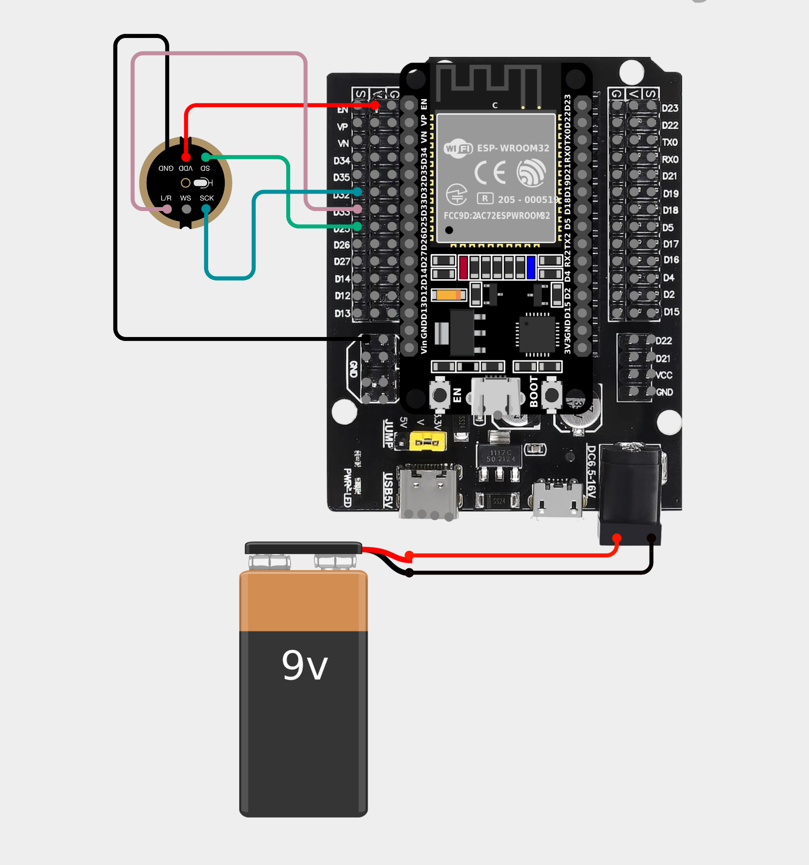
Figure 2. Cirkit Designer Diagram
Connecting the INMP441 Microphone
Connect the VCC pin to 3v power on the ESP32 using a female to female jumper wires. Connect the GND pin to GND pin on the ESP32 using a female to female jumper wires. For the data output wires, the WS pin is used either mono or not, SD to D25, SCK to D32. This setup allows the ESP32 to read digital audio data from the microphone via the I²S interface for further processing and upload to the web server.
Connecting the 9v Battery
To connect the 9v battery, attach the battery to the 9v battery snap connector to power up the device

Procedure for Research Question 1
To investigate the challenges and needs in diagnosing respiratory diseases in low-resource settings, the researchers will conduct interviews and structured surveys with health workers and community leaders. Questions will focus on availability of diagnostic tools, training and knowledge, environmental and infrastructural limitations, consultation time constraints, referral systems, and community awareness. Data will be collected, coded, and analyzed to identify gaps that SmartSteth aims to address.

Procedure for Research Question 2
To determine design features prioritized by health workers, participants will interact with a prototype of SmartSteth. The study will evaluate form factor (size, weight, ergonomics), interface layout (clarity, simplicity, iconography), portability (battery life, ruggedness), ease of maintenance, workflow compatibility, and cost. Feedback will be collected through Likert-scale questionnaires and observational notes, and analyzed to refine the physical and software design of the device.

Procedure for Research Question 3
To assess SmartSteth’s performance metrics in capturing lung sounds, audio recordings will be collected from volunteers using the modified stethoscope. The ESP32 will capture lung sounds for 5–10 seconds and upload them to the web server. The AI classifier will process the audio, and metrics such as signal-to-noise ratio, frequency resolution, latency, sensitivity to different sound types, robustness in noisy environments, and consistency across patient profiles will be evaluated. Comparisons will be made with conventional stethoscope recordings to quantify accuracy and reliability.

Procedure for Research Question 4
To evaluate the intuitiveness and effectiveness of SmartSteth’s GUI, health workers will perform tasks such as navigating the interface, initiating recordings, uploading data, and interpreting results. The study will measure ease of navigation, clarity of instructions and icons, accessibility for users with low digital literacy, multilingual support, error prevention, and training time required for proficiency. Feedback will be collected through observation, post-task interviews, and structured usability questionnaires.

Procedure for Research Question 5
To determine factors influencing acceptance and trust of SmartSteth, the researchers will conduct focus group discussions and interviews with health workers and community leaders. Factors assessed include perceived usefulness and reliability, cultural compatibility, previous experience with digital tools, peer influence and community endorsement, transparency of diagnostic results, and the quality of support and training. Data will be analyzed qualitatively to understand attitudes, barriers, and facilitators for adoption of SmartSteth in the field.
Procedure for Research Question 6
To explore the factors influencing acceptance and trust in SmartSteth, the researchers conducted semi-structured interviews with community health workers and barangay health leaders from selected rural clinics near Puerto Princesa City. The interviews aimed to capture their perceptions, attitudes, and experiences regarding the introduction of AI-driven diagnostic devices in local healthcare settings.

RISK AND SAFETY
The SmartSteth study will identify and mitigate risks to ensure safe, reliable use of the CNN‑driven auscultation instrument for detection of lower respiratory tract diseases in rural health units. Pre‑deployment verification will include functional checks, calibration, and pilot testing to minimize clinical and technical risks such as device malfunction, inadequate respiratory sound capture, and misclassification of results. Infection‑control measures will require sanitizing the stethoscope and all patient‑facing components before and after each use, using approved disinfectants, and enforcing standard PPE protocols for clinicians during data collection. Device cleaning procedures and compatible disinfectants will be documented and trained for all field personnel. Data security and participant privacy will be protected through encrypted audio capture and storage, restricted access to identifiable information, and systematic de‑identification of respiratory sound files and associated metadata. Secure data transfer protocols and role‑based access controls will be used for any cloud or server components. User‑related risks will be addressed by structured training, competency checks, and written operating procedures for health workers performing auscultation and data entry. Clear escalation and referral pathways to local health services will be established for participants with concerning clinical findings. Ongoing safety governance will include routine monitoring and documentation of device performance, an adverse‑event reporting system, and prompt technical support and maintenance by trained personnel. Final acceptance testing and periodic audits will confirm device dependability and adherence to ethical and clinical safety standards in the community setting.

DATA ANALYSIS
The study will use a mixed‑methods analysis: thematic analysis of verbatim interview and focus‑group transcripts will identify user needs, usability issues, and contextual barriers that will be triangulated with quantitative results; conjoint analysis with orthogonal choice tasks and conditional/mixed‑logit estimation will quantify part‑worth utilities and relative attribute importance for device features; respiratory audio will undergo standardized preprocessing (bandpass filtering, normalization, segmentation, augmentation for class balance) and be partitioned into stratified training, validation, and held‑out test sets; CNN performance will be evaluated using sensitivity, specificity, AUC, precision, recall, and F1 (per class and macro/weighted averages) with 95% confidence intervals estimated by bootstrap or cross‑validation, calibration assessed (reliability plots, Brier score), and operating thresholds chosen with clinical rationale; generalizability will be tested via k‑fold cross‑validation and, where possible, an external cohort, with direct comparisons to conventional diagnostics using McNemar’s test or AUC comparisons (DeLong), multiple‑comparison adjustments applied as needed, and error analyses linked to qualitative themes to guide iterative device and workflow refinements.

HUMAN PARTICIPANTS RESEARCH
The evaluation of SmartSteth will involve purposively selected key informants and medical professionals with expertise in diagnosing and managing lower respiratory tract diseases (e.g., pneumonia, asthma, bronchiolitis), including barangay health workers, public health nurses, general practitioners, and pulmonologists active in rural and community health services; data collection will combine semi‑structured interviews, focus groups, and supervised auscultation sessions to capture clinical presentations, local disease terminology, common diagnostic challenges, workflow considerations, and device acceptability and usability, with all benefits and potential risks explained to participants, voluntary participation emphasized with the right to withdraw without penalty, written informed consent obtained before any data collection, confidentiality maintained through de‑identification and secure data handling, and additional safeguards (competency checks for personnel, clinical supervision during auscultation, and clear referral pathways for participants with concerning findings) implemented to protect participant welfare.

HAZARDOUS CHEMICALS, ACTIVITIES, AND DEVICES
The study will involve use of electronic and clinical equipment required for the SmartSteth system and will follow strict safety precautions to support detection of lower respiratory tract diseases. Components include the SmartSteth hardware, mobile devices or tablets for data display, charging adapters and cables, disinfectants (alcohol swabs and approved surface cleaners), and personal protective equipment (gloves, surgical masks, face shields as needed). Study activities comprise device handling, charging, routine cleaning and disinfection between participants, and supervised recording of respiratory sounds during auscultation. Electrical safety practices will be observed for all charging and troubleshooting tasks, and only trained personnel will perform device maintenance or minor electronic repairs. Infection‑control procedures and compatible disinfectants will be documented and taught to field teams, and a qualified clinician or technician will supervise all participant contacts to ensure adherence to safety protocols and proper escalation for any adverse events.
REFERENCES
Topaloglu, N. Y., S. M. Lee, and A. K. Gupta. “Machine Learning–Driven Lung Sound Analysis for Asthma Diagnosis in Low-Resource Settings.” Journal of Medical AI Research 32, no. 5 (2025): 455–472. https://www.mdpi.com/2543-6031/93/5/32.
IEEE Engineering in Medicine and Biology Society. “Neural Networks for Respiratory Sound Analysis: A Comparative Study of Lightweight Models.” IEEE Transactions on Biomedical Engineering 72, no. 3 (2025): 198–210. https://ieeexplore.ieee.org/document/10845461.
Dela Cruz, J. A., et al. (2024). Clinical profile and prescribing patterns of therapy in children with bronchial asthma in a rural site in the Philippines: A retrospective cohort study. Acta Medica Philippina, 58(4), 1–9.
Roxas, R., et al. (2024). Quality of care of adult patients with allergic diseases in urban, rural, and remote primary care sites in the Philippines. Allergy, Asthma & Clinical Immunology, 20(1), 45. https://pubmed.ncbi.nlm.nih.gov/40668119/
Medtigo Journal. (2023). Prevalence of bronchiolitis in children up to two years of age presented to Tehsil Headquarter Hospital Dogar, Central Kurram. Medtigo Journal. https://journal.medtigo.com/prevalence-of-bronchiolitis-in-children-up-to-two-years-of-age-presented-to-tehsil-headquarter-hospital-dogar-central-kurram/

